DIABETIC RETINOPATHY

Diabetic Retinopathy=Diabetics + Retinopathy

* Diabetics: It means a condition where the body has trouble in controlling the amount of sugar in their blood.
* Retinopathy: "retino-" refers to the retina, which is the part of the eye that senses light and sends signals to the brain to create visual images. "Pathy" means disease or disorder, so "retinopathy" is a disease or disorder affecting the retina.

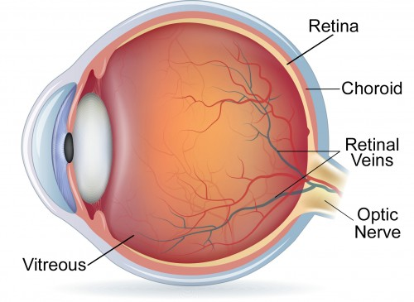

Image Source: <https://sankarfoundation.org/vitreo-retinal/>

* Insulin is a hormone (released from pancreas),that helps the body to use and store sugar from food. When body can’t produce enough insulin,then sugar builds up in blood, leading to diabetes.
* This high blood sugar levels causes diabetics ,mainly there are 2 types of diabetes:

1)Type-1 Diabetes 2)Type-2 Diabetes

|  |  |
| --- | --- |
| **Type-1 Diabetes** | **Type-2 Diabetes** |
| 1. occurs when body’s immune system mistakenly attacks and destroys cells in pancreas,that produces Insulin hormone for digestion of sugar in food. | 1) occurs when body doesn’t use insulin properly (or) doesn’t make enough insulin. This results in overweight and diabetes transferred through heredity. |
| 1. this type of diabetes occurs during childhood or adolescence. | 2) this type of diabetes occurs during old age. |
| 1. Diabetic retinopathy is less prone to this type and can attend for screening for every 5 years | 3)Diabetic Retinopathy is more prone to this type and must attend for screening as soon as possible. |

* Diabetes causes micro-vascular and macro-vascular complications, one of them is DR.
* This high blood sugar levels can damage blood vessels in body, including eyes.DR is a complication of Diabetes.
* This damage to blood vessels in eye leads to a complication called as DIABETIC RETINOPATHY, which if left untreated will cause blindness.
* Few symptoms of DR: (but these symptoms doesn’t guarantee DR)

1)having blurry vision.

2)they might see small spots through their eyes,which are not actually present.

* Manually, DR can be identified through a comprehensive eye examination by an eye doctor(ophthalmologist).They examine eye & look for signs of DR and perform tests such as :

1. DILATED EYE EXAM:eye drops are dropped on patient’s eye to make pupils larger. Then special instruments are used to examine the retina.
2. OPTICAL COHERENCE TOMOGRAPHY: It uses light waves to take pictures of retina, that helps to see if there is swelling/fluid build-up in retina(a sign of DR).
3. FLUORESCEIN ANGIOGRAPHY: a dye(coloured substance) is injected into patient’s arm &pictures are taken as the dye moves through eye blood vessels,to see any blockages/leaks in blood vessels.

* Types of Diabetic Retinopathy

DR is of 2 types ,based on its level of complexity.

1)Proliferative DR : (PDR)

a)Neo-Vascularization Elsewhere(NVE)

b)Neo-Vascularization On Disc(NVD)

2)Non- Proliferative DR (NPDR)

(Proliferation means newly growing vessels. This new cells are called as **NEO-VASCULAR CELLS.** This process of formation of neo-vascular cells is called as **Neovascularization).**

The 2 types of PDR are specified below.

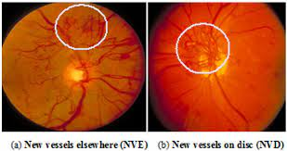

* Other indications of DR include: exudates, hemorrhages, micro aneurysms.